**Continuous Attendance**

***Preference Overview***

This preference sets the maximum time a vehicle may be left unattended. The maximum unattended time has, for example implications for driver changeover delays.

Allowance is made for a stops where a vehicle may be left unattended - for example inside a depot.



There are two preference templates available only one of which may be

used and then only as a single instance.

***Templates Available from Optibus***

*Table 1-1: Templates Summary*

|  |  |  |
| --- | --- | --- |
| **Template Name** | **Purpose** | **Reference** |
| Vehicle Attendance | Sets the maximum unattended time for a vehicle. | **Vehicle Attendance** |
| Vehicle Attendance (Non attendance stop) | Sets maximum unattended time for a vehicle excluding a list of nominated stops where leaving it unattended is per- mitted. | **Vehicle Attendance**  **(Non attendance stop)** |

Sets the maximum unattended time for a vehicle.

**Prerequisites:** None.

**Opening Dialog:**

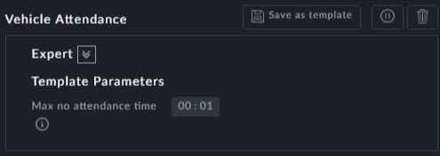

**Points to note:**

**Maximum no attendance time**: This is the maximum time a vehicle may be left unat- tended.

Sets maximum unattended time for a vehicle excluding a list of nominated stops where leaving it unattended is permitted.

**Prerequisites:** None.

**Opening Dialog:**

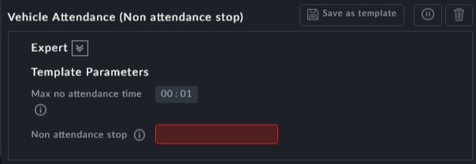

**Points to note:**

**Maximum no attendance time**: This is the maximum time a vehicle may be left unat- tended.



**Non attendance stop**: This is a mandatory field. It is a single stop or a comma delim- ited list of stops at which a vehicle may be left unattended. Make sure that you enter valid stop IDs.

